The Hon’ble Commissioner has approved letter head for GST Commissionerate, Aurangabad. All officers are hereby informed that this letter head be used in official correspondence.

Approved letter head:

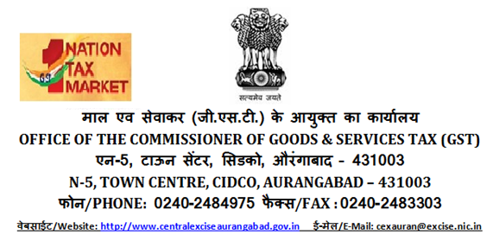

[BODY OF THE LETTER)

